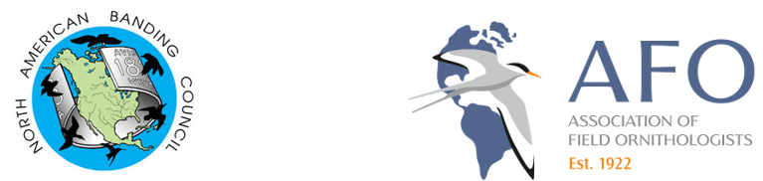
SMALL GRANTS FOR LATIN AMERICAN AND CARIBBEAN BANDING CERTIFICATION SESSIONS
The North American Banding Council (NABC) is soliciting applications for small grants that support the development and certification of Latin American and Caribbean bird banders. Recognizing the integral role bird banding plays in ornithology and avian conservation, these funds are intended to (1) increase the pool of Latin American and Caribbean biologists certified by NABC and (2) promote NABC standards in bird safety and data quality through professional certification. The grants are available due to the generous financial support of the Association of Field Ornithologists (AFO).
Funds will be made available in two forms:
- Groups organizing NABC certification sessions located in Latin America or the Caribbean that culminate in a certification opportunity.
- Latin American or Caribbean biologists attending a bird banding training program based on NABC standards and culminating in a certification opportunity.
Since 2016 grants from this program have supported >80 biologists from 13 countries in Latin America and the Caribbean who participated in banding internships in the United States, Canada, Mexico, Costa Rica, and their home countries.

APPLICATION DEADLINE
March 31, 2026

APPLICATION INSTRUCTIONS FOR GROUP CERTIFICATION SESSIONS
- Grants will be awarded up to $1000 USD.
- Grant requirements:
  - Funds must be used to defray expenses for Trainers and/or participants.
  - The certification session must occur in a Latin American or Caribbean (LAC) country, defined as all countries outside of Canada and the United States.
  - The certification session must include a minimum of one NABC certified Trainer from LAC countries.
  - If the session is to occur in conjunction with a training workshop, the application must demonstrate the feasibility of conducting both events, such as a timeline.
- Preference will be given to sessions that:
  - Employ multiple LAC Trainers and/or LAC Trainers who have yet to participate as NABC Trainers in a certification session.
  - Provide opportunities for certification at the level of Trainer.
  - Charge minimal participant fees.
- Applicants are encouraged to include session promotional materials such as flyers, brochures, advertisements, web sites, etc. in support of their applications.
- The application must be written in English and include:
  - Application Form
  - Budget detailing costs, secured and anticipated support, and financial need.
- More information on organizing a certification session can be found here: http://www.nabanding.net.
- Applications and/or questions should be sent to Ian Ausprey (grants@nabanding.net) with “NABC Application” in the subject line by the deadline indicated above.
APPLICATION FOR A GROUP CERTIFICATION SESSION

BACKGROUND
- Session Location:

- Session Dates:

- Contact Information:

- Partner Organizations:

- Number of Anticipated Participants:

- Grant amount requested:

- Is certification occurring as part of a training session? If so, provide a timeline for both the training and certification.

- Briefly describe your method for selecting participants.

- Proportion of anticipated participants coming from LAC countries:

- Anticipated fee for participants:

- Briefly explain the justification for holding this session (<200 words).

- Please attach a budget showing costs, secured and anticipated support, and financial need.

PARTICIPATING TRAINERS
- Name:
City & Country:
Where certified?
Have you participated as a Trainer in a certification before? Where?

- Name:
City & Country:
Where certified?
Have you participated as a Trainer in a certification before? Where?

- Name:
City & Country:
Where certified?
Have you participated as a Trainer in a certification before? Where?

- Name:
City & Country:
Where certified?
Have you participated as a Trainer in a certification before? Where?

- Name:
City & Country:
Where certified?
Have you participated as a Trainer in a certification before? Where?

- Name:
City & Country:
Where certified?
Have you participated as a Trainer in a certification before? Where?

