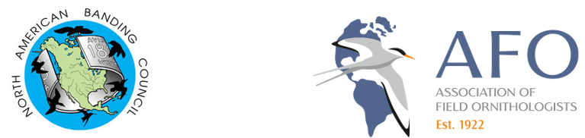
SMALL GRANTS FOR LATIN AMERICAN AND CARIBBEAN BANDING CERTIFICATION SESSIONS
The North American Banding Council (NABC) is soliciting applications for small grants that support the development and certification of Latin American and Caribbean bird banders. Recognizing the integral role bird banding plays in ornithology and avian conservation, these funds are intended to (1) increase the pool of Latin American and Caribbean biologists certified by NABC and (2) promote NABC standards in bird safety and data quality through professional certification. The grants are available due to the generous financial support of the Association of Field Ornithologists (AFO).
Funds will be made available in two forms:
- Groups organizing NABC certification sessions located in Latin America or the Caribbean that culminate in a certification opportunity.
- Latin American or Caribbean biologists attending a bird banding training program based on NABC standards and culminating in a certification opportunity.
Since 2016 grants from this program have supported >60 biologists from >10 countries in Latin America who participated in banding internships in the United States, Canada, Mexico, Costa Rica, and their home countries.

APPLICATION DEADLINE
March 31, 2025

Please note that grants cannot be provided to individuals attending a group session that is already being funded by this program. If you are applying to participate in a group certification session, please check with the session organizers first to determine if the event is already receiving funding from the NABC-AFO Small Grants Program.
INSTRUCTIONS FOR INDIVIDUALS ATTENDING A TRAINING PROGRAM
- Grants will be awarded up to $500 USD.
- Grants can be used to defray travel expenses, visa fees, and/or workshop fees. They cannot be used to cover stipends, salaries, or living expenses.
- Grants are available for individuals attending any type of training program that culminates in an opportunity for certification. However, preference will be given for participation in long-term programs that provide extensive personal and professional development (eg., internships). Please note that funds cannot be awarded to participants attending a workshop that is already receiving funds from this granting program. A partial list of programs that offer formal internship or volunteer opportunities is here: https://nabanding.net/passerines/additional-resources/.
- Preference will be given to individuals with demonstrated connections to an established bird banding, scientific, or biological conservation program in their native country.
- The application must demonstrate that the training program culminates in a NABC certification opportunity.
- The application must be written in English and include:
  - Application Form
  - CV with contact information for two references
- Information on banding programs in North America that may provide certification opportunities can be found here: https://nabanding.net/passerines/additional-resources/.
- Applications and/or questions should be sent to Ian Ausprey (grants@nabanding.net) with “NABC Application” in the subject line by the deadline indicated above.
APPLICATION FOR INDIVIDUALS ATTENDING A TRAINING PROGRAM
- Name:

- Address:

- Email:

- Date of Birth:

- Name of banding program(s) in your country with which you are associated:

- Type of Training Program:

- Name of Training Organization:

- Dates for Training Program:

- Does this Training Program provide an opportunity for NABC certification?

- Contact information for member of Training Organization who can verify your acceptance or pending acceptance in their Training Program:

- Amount of funding requested:

- Please write a brief statement explaining (1) why you wish to participate in the training program, (2) how you will use the training opportunity and certification in your native country after the training program concludes, and (3) how the funds will be used (< 200 words).

- Please attach your CV showing relevant experience and contact information for two references.

